MyConnection Detail for Test #134951

Summary
This report refers to a connection test carried out by IP address 187.53.116.1 on 25 Jul 2010 17:58:55 GMT-03:00.
Download speed | 616 Kbps
Upload speed | 86 Kbps
QOS | 94 %
RTT | 105 ms
Max Delay | 639 ms
Avg Delay | 26 ms
Max Bandwidth | 616 Kbps
Route Speed | 4993 Kbps
Forced Idle | 0 %
Route Conc | 1.0
Download test | s
Upload test | s

Download Test
The graphs below illustrate various properties of your Internet connection obtained during the test process. They show the throughput, data and service quality of your connection.
Download speed graph: This graph illustrates how your download speed fluctuates over time. You may notice that the maximum download speed shown on the graph is more than the connection speed rated by your ISP. This is usually due to how your connection is regulated. For example, an ISP may supply a 10 Mbit connection by allowing 100 Mbit for 10ms, and pause for 90ms.
The higher the download speed, the better, but a quality connection will also demonstrate very little fluctuation in download speeds. If the graph below shows a rapidly changing speed then this indicates that the data is impacted and the quality of service degraded. Whilst this does not necessarily affect applications such as email it will definitely affect multimedia applications such as video or voice.
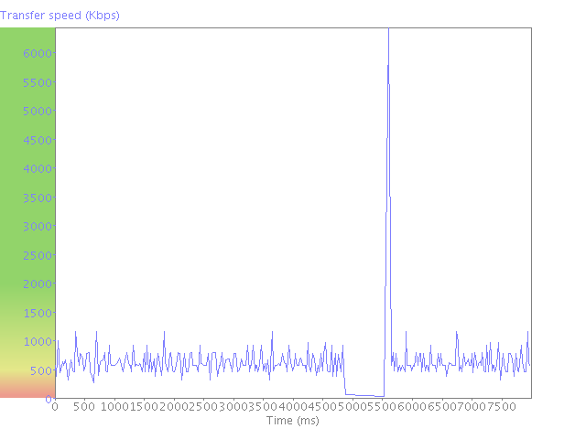
TCP pause graph: Data is sent across the Internet in "blocks". Usually a connection will send a block of data and pause before sending the next. (This pause is known as the TCP pause.) The graph illustrates the TCP pause between receiving subsequent blocks of data. If the pauses become excessive it means that the connection throughput is being degraded.
A good connection will have both a low TCP pause (less than 20 ms), and also demonstrate very little fluctuation in the TCP pause values. This in essence defines a quality of data as it defines how much of the test time was spent actually transmitting data versus being idle waiting for data to arrive.
The - - - - - line shows the maximum TCP pause recorded. If you see many TCP pauses exceeding 80-100ms then it is likely that the connection test is spending more time waiting for data than moving data. If the TCP pause pattern looks very symmetrical and regular then it may indicate that there is a throttling process managing/restricting the data flow. If the TCP pause pattern is more erratic and variable then it would indicate network delays as a result of congestion or other network problems.
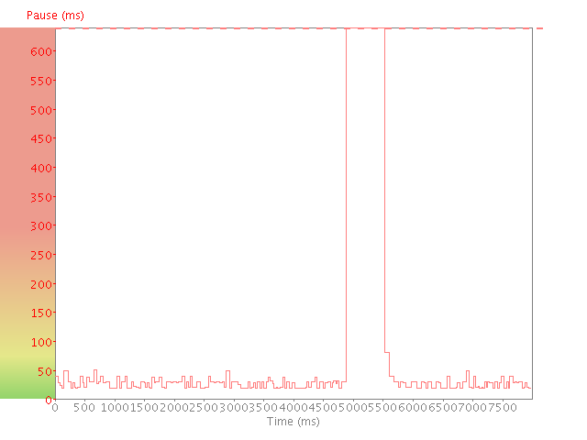

Parte superior do formulário
You can download the raw data used to produce these graphs.
Download data in format
Parte inferior do formulário

Upload Test
The graphs below illustrate various properties of your Internet connection obtained during the test process. They show the throughput, data and service quality of your connection.
Upload speed graph: This graph illustrates how your upload speed fluctuates over time. You may notice that the maximum upload speed shown on the graph is more than the connection speed rated by your ISP. This is usually due to how your connection is regulated. For example, an ISP may supply a 10 Mbit connection by allowing 100 Mbit for 10ms, and pause for 90ms.
The higher the upload speed, the better, but a quality connection will also demonstrate very little fluctuation in upload speeds. If the graph below shows a rapidly changing speed then this indicates that the data is impacted and the quality of service degraded. Whilst this does not necessarily affect applications such as email it will definitely affect multimedia applications such as video or voice.
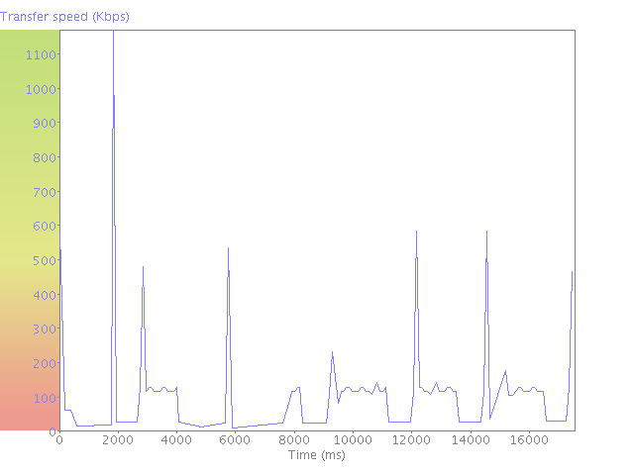
TCP pause graph: Data is sent across the Internet in "blocks". Usually a connection will send a block of data and pause before sending the next. (This pause is known as the TCP pause.) The graph illustrates the TCP pause between receiving subsequent blocks of data. If the pauses become excessive it means that the connection throughput is being degraded.
A good connection will have both a low TCP pause (less than 20 ms), and also demonstrate very little fluctuation in the TCP pause values. This in essence defines a quality of data as it defines how much of the test time was spent actually transmitting data versus being idle waiting for data to arrive.
The - - - - - line shows the maximum TCP pause recorded. If you see many TCP pauses exceeding 80-100ms then it is likely that the connection test is spending more time waiting for data than moving data. If the TCP pause pattern looks very symmetrical and regular then it may indicate that there is a throttling process managing/restricting the data flow. If the TCP pause pattern is more erratic and variable then it would indicate network delays as a result of congestion or other network problems.
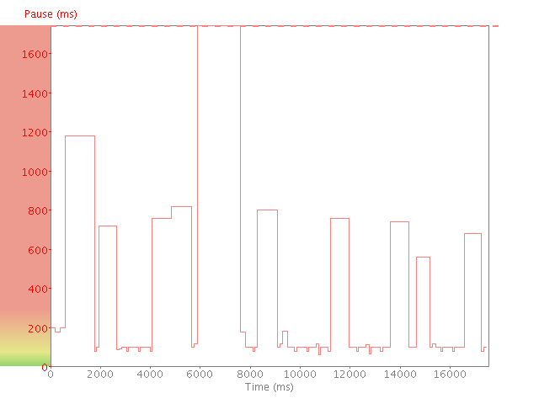

Parte superior do formulário
You can download the raw data used to produce these graphs.
Download data in format
Parte inferior do formulário

